Web Development (Introduction) WEDE5020

Zakwantu Projects and Services Website

Gqamile Mapela

ST10457235

22 August 2025

Contents

Zakwantu Projects & Services (ZPS) 3

1. Organisation Overview 3

2. Website Goals and Objectives 3

3. Current Website Analysis 3

4. Proposed Website Features and Functionality 3

5. Design and User Experience 3

6. Technical Requirements 7

7. Timeline and Milestones 7

8. Budget 7

References 8

GitHub Link 8

# Zakwantu Projects & Services (ZPS)



## 1. Organisation Overview

**Name:** Zakwantu Projects & Services (ZPS)

* **History:** ZPS is based in the Eastern Cape and works in rural areas such as Somerset East, Cookhouse, Bedford and Adelaide. With over 20 years of combined experience in community development, the organisation has built its creditability and a strong presence in addressing educational and social issues/challenges.
* **Mission & Vision:** To empower learners and communities to become resilient and self-sufficient through education, community support and training
* **Target Audience:** Students/learners in rural areas, parents and local community stakeholders.

## 2. Website Goals and Objectives

* **Goals:** To provide a user friendly and informative website, modernise communication, enable online bursary applications, and increase transparency to attract more donations by showcasing past and recent projects and success stories.
* **KPIs:** Number of bursary applications submitted online, increase in donor contributions, monthly visitor traffic, positive feedback from stakeholders

## 3. Current Website Analysis

* **Strengths:** Active in projects and trusted in the local communities
* **Weaknesses:** Doesn’t have much of an online presence; reliance on paperwork and on WhatsApp, they don’t have much of a social media presence
* **Areas for Improvement:** Build a professional, accessible website to host applications, updates, and resources.

## 4. Proposed Website Features and Functionality

* Homepage, About Us, Our Services, Resources, Contact Us
* Online bursary application form, donation portal, events calendar, our work (success stories and recent work)

## 5. Design and User Experience

* **Colour Scheme:** Grey, white (clean), blue (trust) and orange (ZPS’s colours).
* **Typography:** Clean sans-serif fonts for readability.
* **Layout & UX:** Simple and structured, easy to navigate for learners, donors, and stakeholders but with a modern look. Call to action buttons on key pages, hero section on homepage. I’d also like to use the picture they have for their business profile as the background for the web pages. The images I’ll be using in the website will all be from the organisations own pictures.
* **Wireframes:**

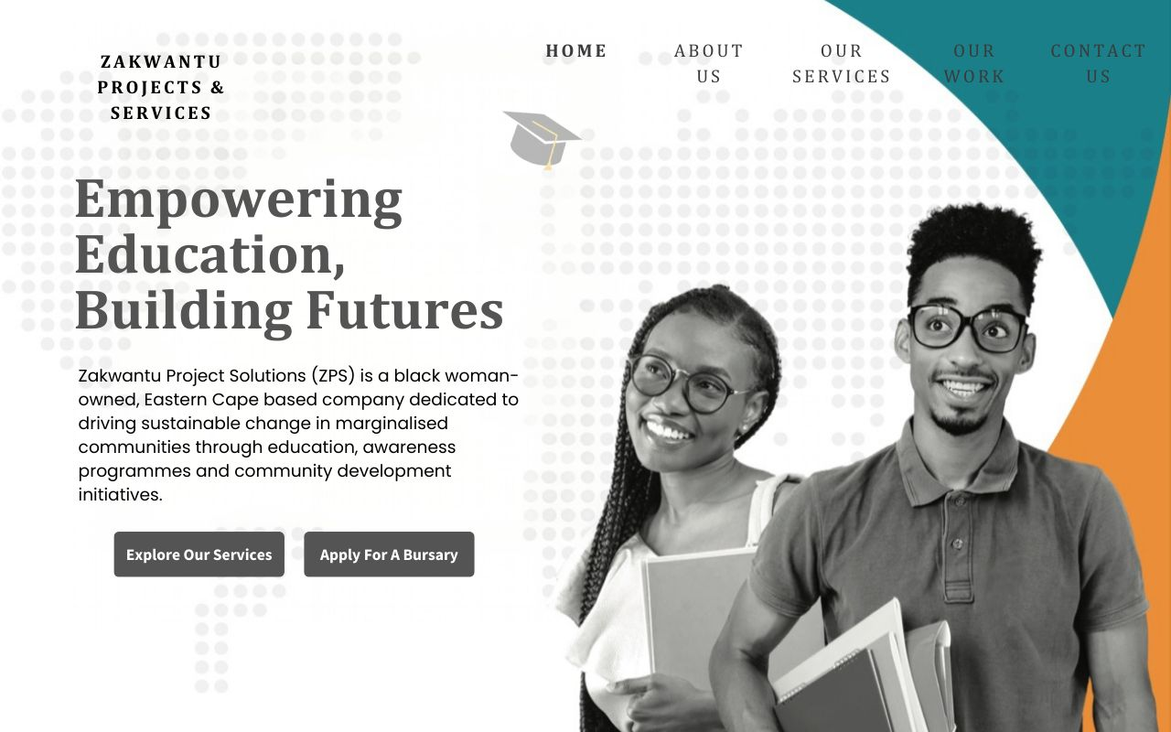

Figure : Homepage

Wireframe 1: Home Page

For my home page, the background picture will be the one with the students but the rest would not have them shown.

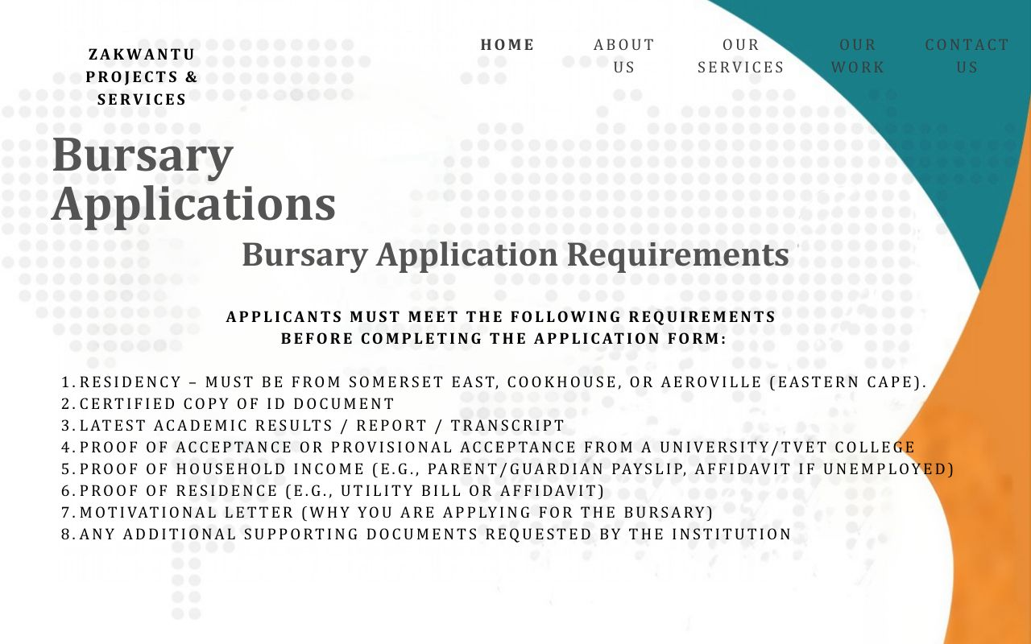

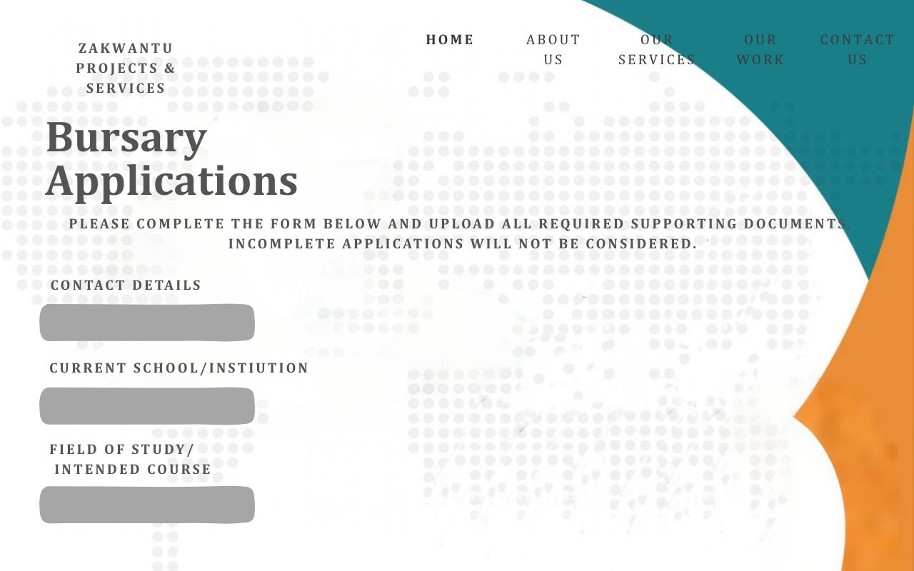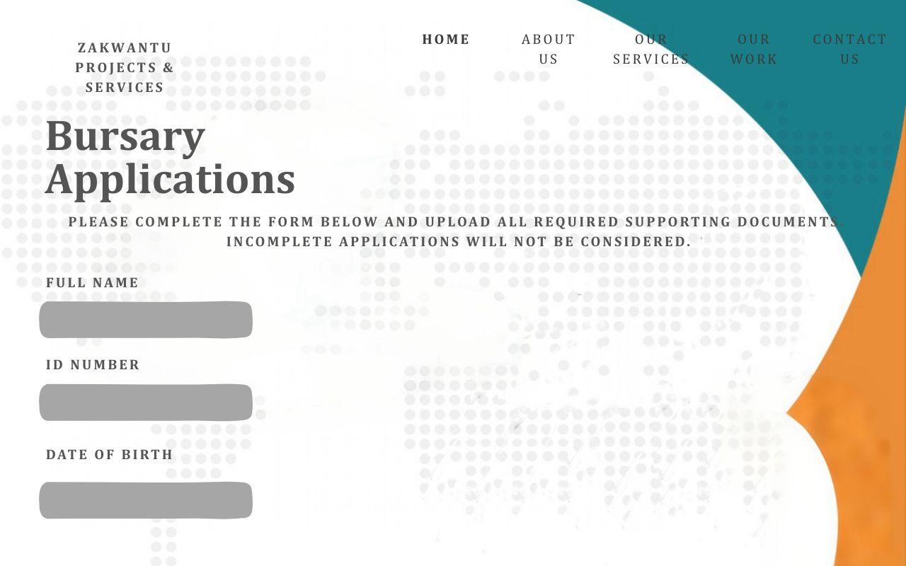

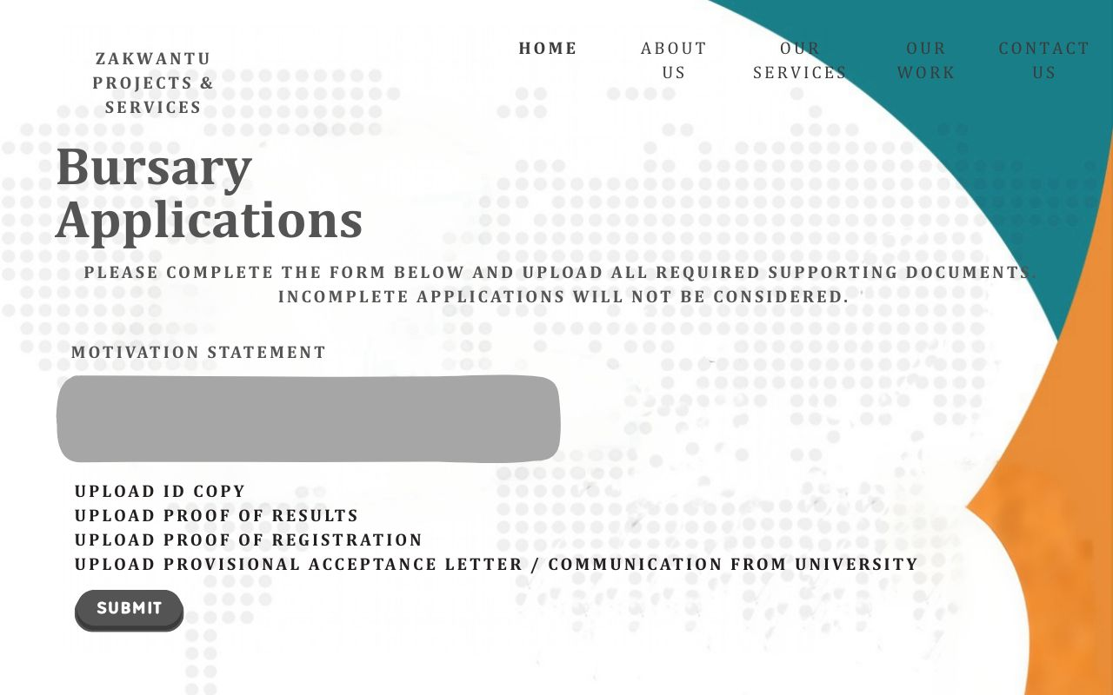

Wireframe 2: Bursary Applications

* **Sitemap:**

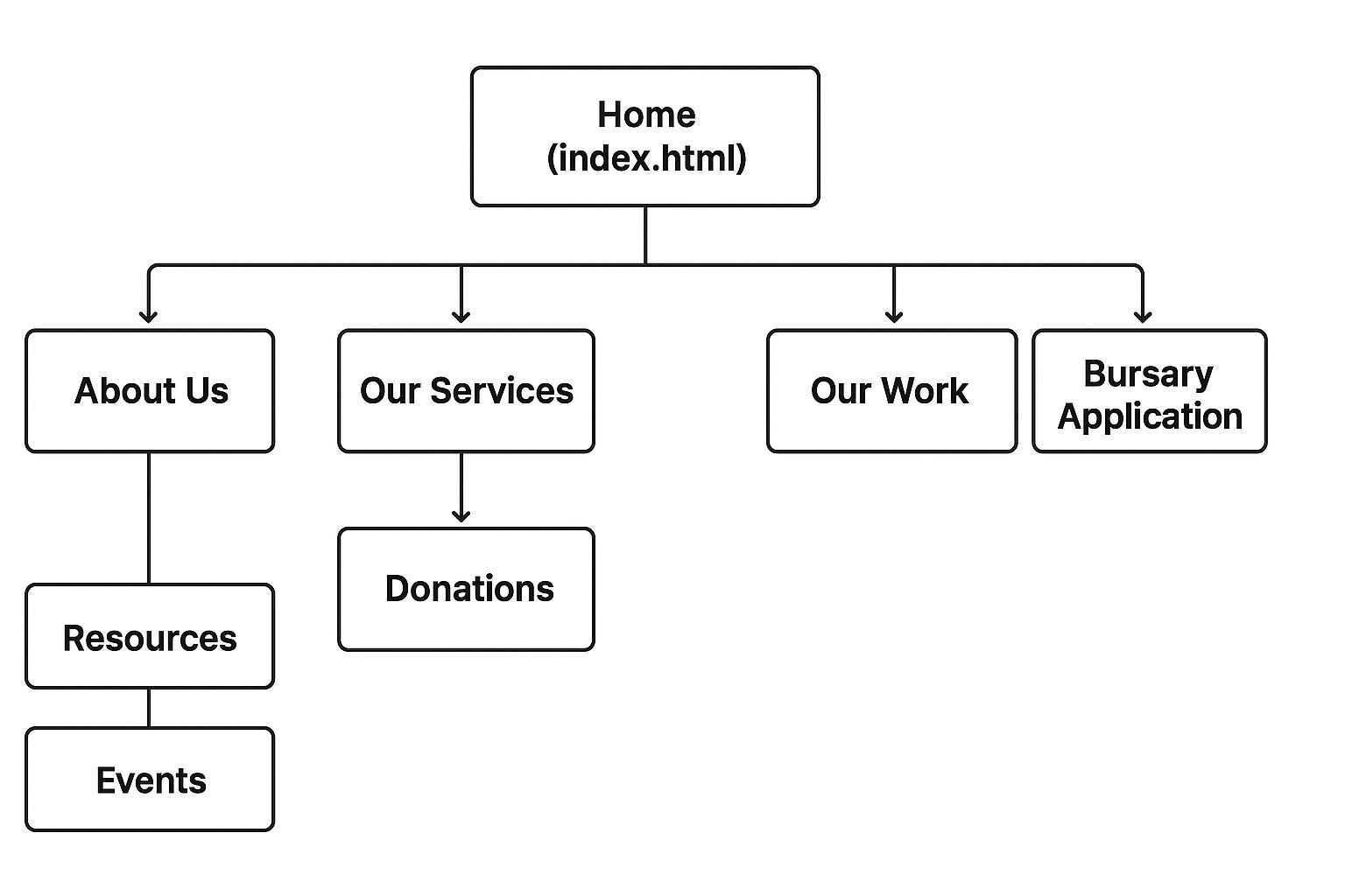

I decided to not have all my html pages showing on my header because I don’t think they’d all fit and it might just be overwhelming for the users so I decided to have buttons within the other pages for the ones that aren’t on the header.

## 6. Technical Requirements

* **Hosting/domain:** South African provider
* **Programming:** HTML, CSS, JavaScript.
* **Tools:** VS Code, GitHub for submission, Canva for the wireframes, Hypic for the unwanted things from the background picture I’ll be using.
* **Assets:** I’ll be using the pictures from the organisations unpublished reports and business profile.

## 7. Timeline and Milestones

|  |  |  |  |
| --- | --- | --- | --- |
| **Task** | **Start Date** | **End Date** | **Milestones** |
| Project Planning | 14 August 2025 | 17 August 2025 | Both proposals approved. I ended up choosing Zakwantu. |
| HTML Structure | 19 August 2025 | 27 August 2025 | Web pages created |
| CSS Styling | 28 August 2025 | 29 September 2025 | Responsive design would be applied and picture as a background would be added. |
| JS Functionality | 5 September 2025 | 29 September 2025 | The application form and donation form would have working interactive elements. |
| Testing & Debugging | 6 September 2025 | 29 September 2025 | Website would be fully functional |
| Final Submission |  | 29 September 2025 | Complete documentation and GitHub submission |
|  |  |  |  |

## 8. Budget

Estimated R15 000 to R20 000 for development, hosting and the maintenance.

# References

* Zakwantu Projects & Services. (2024). Business Profile. Unpublished organisational document.
* Zakwantu Projects & Services. (2025) Bursary Programme Presentation. Unpublished organisational document.

# GitHub Link

* <https://github.com/ST10457235/WEDE-PART-1>